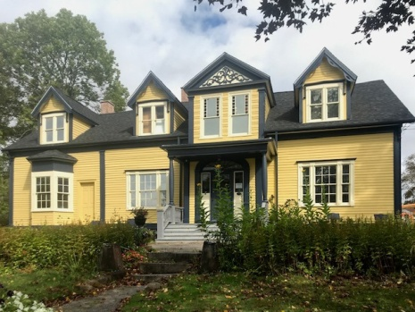
Cumberland Museum Society 2022 Plant Sale
Plants will be ready for pick up 21 May from 8 AM to 4 PM.
Cumberland County Museum and Archives, 150 Church St., Amherst.
Proceeds support museum programs and new exhibit development.
Grove Cottage 2022
Order Form
Name: __________________________________________________________________________________
Address: ________________________________________________________________________________
email: __________________________________________ Phone: _________________________________
ITEM | Colour | QTY | Price | Total
12" Hanging Basket
 | Multicolour |  | X $30
 | Pink |  | X $30
 | Purple |  | X $30
4" Supertunias [5 pack]
 | Black Cherry |  | X $20
 | Blue Skies |  | X $20
 | Limoncello |  | X $20
 | Royal Velvet |  | X $20
 | Bordeaux |  | X $20
6" Geraniums [4 pack]
 | Salmon |  | X $26
 | Violet [Hot Pink] |  | X $26
 | Rocky Mountain Red |  | X $26
6" Begonias [4 pack]
 | Yellow |  | X $26
 | Red |  | X $26
 | Orange |  | X $26
 | Pink |  | X $26

Please make cheques payable to "Cumberland Museum Society"  Order online at cumberlandmuseum.net. We also accept orders by VISA, Mastercard, Debit, and etransfer. For questions, please contact the museum at 902-667-2561 | Grand Total
The information contained in this message may be confidential information, and may also be the subject of legal professional privilege. If you are not the intended recipient, any use, interference with, disclosure or copying of this material is unauthorized and prohibited. If you have received this message in error, please telephone Gordon Goodwin at the number above.

